Using A Mobile Learning Application to Enhance Learning Retention Among Technology Student Support Staff
Joeleen Monclova
California State University, San Bernardino
March 18, 2019

Abstract
The purpose of this paper aims to explore if utilizing the Slack mobile application would increase workplace knowledge among the technology student staff support in the USA, as well as find their perceptions using the mobile application. Mobile learning is not just for games and simulations but can be utilized for educational purposes or learning activities.
Introduction
While the ATI Department provides an array of services to the CSUSB campus community, one important aspect is Faculty support. Distance Learning technology support falls under that feature of faculty support services. Currently, our level of support includes; technology set up for equipment in ATI’s designated classrooms, as well as microphone/video connection for Zoom connection to our sister campus PDC. Due to a shortage of ATI support staff, relying on our student assistants to help provide extra support for these classes. One of the roadblocks that we encountered with student support staff is a knowledge gap. Each student had been previously given a 1-hour face-to-face training session before the quarter began covering all related processes of setting up distance learning classes but have yet to fully grasp each step. The student support staff is frequently relying on superior staff intervening to complete the task. As a result, this purpose of this research was to explore the effectiveness of using mobile learning to enhance learning. “The concept of ‘anytime’ and ‘anyplace’ of mobile learning should be utilized in enhancing the pedagogical activities in delivering lessons.” (Bidan & Ziden, 2012. p.721).
Literature Review

Adoption of Mobile Learning

With the convenience of mobile technology and evolution of educational transfer tools, mobile instruction has increased over the years. “With the growing acceptance of mobile devices, it is important that adequate learning and educational approaches are developed in order to utilize the benefits of mobile devices effectively for an enhanced learning.” (Badursha, Sarran & Shibli, 2016. p.331). In this study, I was looking to explore alternative methods to the traditional face-to-face instruction by utilizing mobile application to enhance student support knowledge through collaboration. Group collaboration mobile apps provide the opportunity to support and foster learning among peers. With the benefits of group collaboration through mobile learning, the opportunity arises to develop an environment for learning to take place and provide topics for interaction and teamwork to naturally occur and move forward for collaboration. According to Wu and Reychav, “improving learning and instructional effectiveness through group learning to strengthen the individual learning is the goal and aspiration of the academic community.” (Reychav & Wu, 2015. p.521).

Attitudes and Perceptions of Mobile Learning Applications

With the affordability and the appeal of mobile technology, alternative methods
to improve the knowledge gap continues to grow. “Young people nowadays have a positive attitude towards using mobile apps in daily life as well as for learning”. (Style Han Wai, 2016, p. 44). The convenience is not only utilized by the students, it can offer alternative methods of instruction for educators. “Mobile technology is the number one tool used for communicating, learning and discovery, making such tasks easier on both library stuff and students, while enhancing the overall learning and research experience.” (Al-Daihani, Almutairi, Alonaizi, & Mubarak, 2018, p. 330).
Research Questions
With the research topic studied: Using A Mobile Learning Application to Enhance Learning Retention Among Technology Student Support Staff, this paper aimed to address the following questions:
RQ1: Does integrating the Slack Application improve student work process execution?
RQ2: What is the student perception of using the Slack mobile application?
By providing an alternative method of learning activities using a mobile application for our student support staff, I studied to find if there was a possibility to reduce the knowledge gap. With RQ1, the question aimed to find a connection of group collaboration mobile apps and student work progress. “Collaborative learning environments, or small groups, are recognized by faculty and students as one effective strategy for promoting student engagement and learning”. (Heflin, Shewmaker, & Nguyen, 2016, p. 92). With RQ2, the question aimed to find out what the overall perception using the mobile application to aid work process knowledge.
Methodology

Research Design

Mixed method design was utilized for this study. It explored the explanatory sequence initially with the quantitative research, followed by the qualitative research.
RQ1 was explored by using the quantitative method. I developed an observational checklist to observe and compare the frequency and areas that need reinforcement of work processes before and after integrating the Slack mobile application. These observations reviewed the set-up of equipment, technology and if each step was completed. Both checklists followed the same observational criteria and categories. The independent variable from this study was the Slack mobile application and the dependent variable was the student support staff performance. While using the Slack mobile application, I incorporated polling quizzes relating to the process that was to be learned. I also tallied the use by each student utilizing the application and observe the interaction that occurs. RQ2 was explored by using the qualitative method. This portion was conducted by a 15-minute one-on-one interview to understand the student support staff perception of the use of the mobile application that was incorporated and to see if peer collaboration in Slack was useful to enhance learning. I also conducted a 10-minute process assessment to verify what was learned.
The sample group was collected using sequential explanatory methods due to the mixed method approach of the research. The sample group studied comprised of the student assistant technology support staff in higher education in USA. The proposed sample utilized was the convenience sample and included a non-random selection for the participants for both qualitative and qualitive studies, due to the fact the research study is specifically targeted the student assistant support staff that I directed. There was a total of five participants sampled in this study.

Instrument Development

To address RQ1, the sample group was observed based on a specific criterion or coding. The “prior” and “after” observations were conducted for a week. The observation took place at a non-random time that was determined based on class schedule and work schedule. There were six categories that I needed to note based on frequent inquiries. These categories included; 1) Class reminder, 2) Equipment Process Reminder, 3) Laptop Check Out Reminder, 4) Battery check Reminder, 5) Audio/Video Check with PDC, 6) Setup Process.
To address RQ2, questions for face-to-face interviews were created using the Qualtrics survey. It consisted of ten questions; three demographic questions, three questions examining about the mobile application utilization, one Likert scale and two open-ended questions that will be verbally asked. I conducted the face-to-face interviews with each participant separately not only collect the answers from the specified questions, but to obtain additional information that the participant would like to disclose.
When developing instruments for both research questions, validity and reliability were also taken under consideration. For both RQ’s validity was ensured prior to conducting any study, I gave each participant an identification number to ensure privacy and to allow the ability to answer freely throughout the study. For RQ1, I defined categories to ensure what exactly was needed to be observed. I also created the category legend and excel spreadsheet to track and log each participant before the observation took place to ensure validity of the study. Thus, with observing the five participants, with the same process and criterion for each observation, the study became reliable because the process is conducted the exact way. Reliability was checked frequently due to the small sample size given. Data was crossed check by an internal reviewer and expert of the work processes. According to McMillan, “use internal consistency when the purpose of your instrument is to give you a status measure of a single trait.” (McMillan, 2016, p.163).

Data Collection Methods

For this research study, data collection methods included; observational checklists for the quantitative data, a 10-minute observation that included field notes as well as a face-to-face exit interview for each participant for the qualitative data. The sample group recruited included, five participants; three males and two females, aged from 18 – 31 years old, and college level ranging from freshman to senior level. The observations were in a non-controlled setting and were guided by a general problem known to the area for student work performance. These observations were a low interference, to allow I, the observer to remain unbiased. According to McMillan, “Either behaviors are present or not, and the observer makes no judgment or interpretation.” (McMillian, 2016, p.193). Observations were conducted before the introduction of the Slack application and after observations. The observations before introducing Slack were over a course of seven working days and the post observations after Slack was introduced was over a period of six working days. Prior to introducing Slack, I observed six categories following specific factors that were to be observed. Following the first set of observations, I integrated the Slack mobile app to each participant to provide a flexible learning environment for a week. “The mobility of these devices means that students are now engaging with learning content in brief spurts, on-the-go, in the hallway, during lunch, and even in the classroom itself.” (Cassidy, et al., 2014, p. 124). Post observation after the introduction provided an additional category of no intervention needed.
10-minute observations were also conducted of each participant with recorded field notes have been conducted as well as five face-to-face exit interviews. For each observation, I observed that of a passive participant and did not intervene throughout the process. Not only behaviors were noted, but an understanding of the level of knowledge each participant had to complete the task that was given. After the observations concluded, each interview was approximately 15-minutes and followed a semi-structured set of prespecified interview questions to offer the flexibility to ask follow up questions between the interviewee and the interviewer.
Data Analysis
For RQ1, observational checklists were collected to have to provide an overview of the frequency of what was observed for the specified categories. Descriptive statistics were calculated and analyzed including frequency to provide further analysis. For RQ2, a 10-minute observation of a mini assessment conducting an instructional task from each participant, where field notes were collected. These field notes collected included descriptive and reflective notes. The notes also include behavior actions and reactions when trying to complete the tasks that was asked of them. “According to Moreira, Pereira, Durao, & Ferreira “aspects such as the sample size, the way the questionnaire is prepared, the questions formulation, data analysis, error margins, the selection of individual process of who should compose the sample, among other things, are important and they should be taken into account for any investigation”. (Moreira, Pereira, Durao, & Ferreira, 2018, p. 984).
In order to find the perception of the participants using Slack, a semi-structured face-to-face interview was conducted. Preliminary responses from the interview were categorized in general groups based on each question to provide information on demographics. The seven-point Likert scale questions were also given a correlated number and grouped into categories for participants perception of the application ranging from “Strongly Disagree” (1) to “Strongly Agree” (7). The interview survey data were added to an excel spreadsheet.
This information was coded for further analysis through data interpretation, followed by synthesizing to find a common theme or pattern. Creditability of the study was verified through member checking. According to Pimmer, Mateescru, & Grohbiel, the “selection process should also allow a consideration of the nuanced theoretical understandings of difference studies and the elicitation of relationships across the selected works.” (Pimmer, Mateescru, & Grohbiel, 2016, p. 492). Completed surveys were scanned to each participant to verify everything has been correctly noted. According to McMillan, member checking allows the researcher to “check with the participants about codes, categories, themes, patterns, and other findings to see whether these are viewed by the participants as fair, reasonable, accurate, and compete.” (McMillan, 2016, p. 357).
Findings

Quantitative Data Collection

After observing five participants prior to introducing the Slack mobile application, the frequency results were a large number overall. Each participant needed more assistance to complete their daily tasks. After introducing Slack, the frequency was considerably lower than the previous observation. As you can see in Table 1, the numbers decreased after the Slack mobile integration. One category observed did not have any effect on the results; the category included “participants did not work, or there were no classes to support”. Another observation included that there was not intervening by the observer after Slack was introduced.
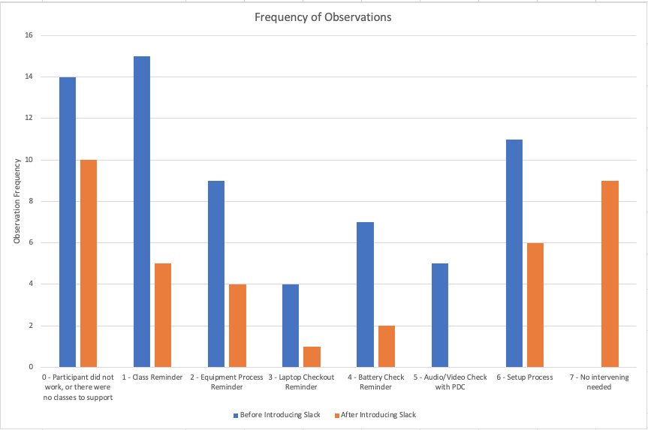
Table 1

Qualitative Data Collection

While observing the 10-minute mini assessment for each participant, field notes were collected. Results indicated that four out of the five participants were confident when asked to set up the instructional task. P1 was the only participant to complete the task at 100% with no errors. P2, P3 and P5 had minimal errors with missing only 1-2 components throughout the assessment. P4 had more trouble setting up the instructional tasks. Cleary was more nervous than all other participants when setting up. Forgot many steps of the process and could not complete the task.
Following the assessment, each participant was interviewed for 15-minutes regarding their experience with the Slack mobile application. Results indicated that all participants utilized Slack on a daily basis and the features utilized was the group chat, and polling bot, with a couple of participants additionally using the direct message chat. P1, P2, and P4 initiated a conversation 1-2 times, while P3 utilized it 3-4 times and P5 utilized it 2-3 times. Table 2 results reflect a sample of the Likert scale responses. The six questions inquired about the participants perception of using the Slack mobile application. Q7.1 had mixed results of 40% of the participants indicating Strongly Agree that it was easy to use, while 40% indicated they Agree and 20% indicated they Neither Agree nor Disagree. For Q7.2 results indicated that all participants either Strongly Agree or Agree that using Slack would increase their productivity at work. Q7.3 all participants Strongly Agree 100% Slack improved their performance setting up for DL classes. Mixed results were collected for Q7.4 with participants 60% agreeing Strongly Agree, 20% indicating Agree and 20% indicating Neither Agree nor Disagree that interaction with Slack would be clear and understandable. Q7.5 provided mixed results as well, 40% indicated Strongly Agree, while 20% indicated Agree, but 40% could not respond due to the question being confusing in regard to finding Slack useful in their daily work. The last question Q7.6 60% of participants indicated Strongly Agree 40% indicated Agree for Slack enhancing their effectiveness in their work.
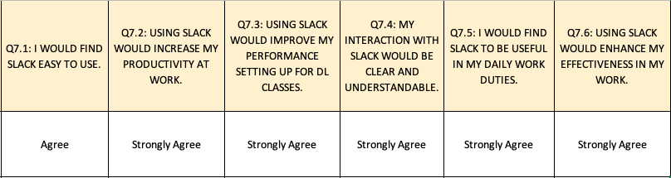
Table 2

For the first open-ended questions, results indicated a mixture of responses for finding most useful from Slack including; navigation easy, ease of use super easy, polling features go beyond group chat, availability of answers reviewed from previous messages, daily questions from other participants, polling questions and the ability to chat questions. The second open-ended question inquired what the participants liked least about Slack, results included; the design of the polling bot, did not get the reason of the polling bot, notifications of a new response, layout could be more clear, distinguish the users, navigation of the group chat, and Slack channels were confusing.
Discussion
After analyzing the observational checklist data collected for RQ1, results indicated that the Slack mobile application did appear to have a positive effect to improve student work process execution. Prior to introducing Slack, data results indicated a higher amount of interference in order for the participants to complete the tasks. After the integration of Slack, interference declined, and participants needed little to no help completing the tasks. Results from the mini assessment had one outlier. Four out of five participants completed the task with little to no intervention, while one participant could not complete the task. These results indicate that possibly the one participant was not fully prepared for the assessment or had an off day.
After reviewing the results collected for RQ2, results indicated mostly all participants strongly agreed that Slack did in fact improve their performance. With a few answers indicating they neither agreed nor disagree on certain questions, overall it was a positive reaction to the mobile application. Open-ended question (Q9) results indicated that there were many features of the application that the participants found very useful including, review of previous questions and the group chat to rely on group collaboration for answers or help. According to Fang, Miao and Wang, “students need to interact with mobile device and environment, which may increase students’ cognitive load and influence the learning performance of students and the perceptions of learning activities”. (Fang, Miao and Wang, 2018, p.917). Open-ended question (Q10) results indicated that navigation wasn’t as easy, nor the layout was not clear enough to distinguish each user. These results suggest that maybe Slack is good but lacks intuitive features.
Implications
Implications include choosing an alternative mobile app due to limited features the participants expressed. Group collaboration was facilitated but some participants were dissatisfied with the navigation. The issue arose differentiating between participants. Channels within the app caused confusions as well and possibly reduced conversations among participants.
Conclusion
After reviewing the results of both sets of data, the results indicated the mobile app did reduce the knowledge gap for the participants through group collaboration. Assistance needed after Slack was introduced, decreased significantly allowing participants to complete daily work processes accurately. With limitations of the interface of the mobile applications, the participants were still able to transfer the information given and apply it to work processes. Further research might be needed to address the outlier in the study, and to address if the correct mobile app was selected for this current study.

Limitations

Limitations of the study included the timing of the weekly observations. Each participant worked at a different time that may or may not have had an influence on the outcome of the results. Another limitation, when conducting the face-to-face interviews if I should have asked an external person to conduct the study, in case the participants felt they couldn’t give an honest answer about their perception. Another limitation was that I did not fully understand each feature of the mobile application before introducing the application to the participants.

Recommendations
Recommendations for future studies include longer observational periods to get a better understanding of the knowledge gaps. A week for each observation gave enough data for frequency interpretation, but more information is needed to truly assess and determine each category observed. Increasing the sample size might also help for future studies to better assess the mobile application’s influence on the participants. Another recommendation would to observe on additional work processes and not just one of the instructional tasks, to see if there are any additional gaps in knowledge. Another recommendation would to be fully versed in the mobile application that is to be deployed to have a full understanding of what is to be utilized. Last recommendation to include clear and understandable interview questions so participants are comfortable and confident to answer the question.

Reflection:
Throughout this course, I enjoyed getting to learn the research project. Going through the motions of planning a topic, exploring the data collection methods and reviewing the results was exciting. It was exciting to see the final completion of the whole study and how much involvement it needed. The challenges that I encountered mostly, was the research questions. In the beginning, I was pretty sure that my questions were good enough but figuring out the right verbiage took some time. I changed one question about three times, but I finally got it with the help of Professor Baek! (Thank you!!) The lesson learned from this study is to keep exploring a topic. The research may stop for one topic, but then it can open the doors for future studies.

Works Cited
Al-Daihani, S. M., Almutairi, M. R., Alonaizi, R., & Mubarak, S. (2018). Perceptions toward academic library app implementation. Emerald Insight, 330-341.

Badursha, N., Sarrab, M., & Shibli, I. A. (2016). An emperical study of factors driving the adoption of mobile learning in omani higher education. International Review of Research in Open and Distributed Learning, 1-20.

Bindin, S., & Ziden, A. A. (2012). Adoption and application of mobile learning in the education. Procedia Social and Behavioral Sciences, 720-729.

Cassidy, E. D., Colmenares, A., Jones, G., ManolovitZ, T., Shen, L., & Vieira, S. (2014). Higher Education and Emerging Technologies: Shifting Trends in Student Usage. The Journal of Academic Librarianship, 124-133.

Heflin, H., Shewmaker, J., & Nguyen, J. (2016). Impact of mobile technology on student attitudes, engagement, and learning. Computers & Education, 91-99.

McMillan, J. H. (2016). Fundamentals of Educational Research. Boston: Pearson.

Moreira, F., Pereira, C. S., Durao, N., & Ferreira, M. J. (2018). A comparative study about mobile learning in Iberian PeninsulaUniversities: Are professors ready? Telematics and Informatics, 979-992.

Pimmer, C., Mateescru, M., & Grohbiel, U. (2016). Mobile and ubiquitous learning in higher education settings. A systematic review of empirical studies. Computers in Human Behavior, 490-501.

Reychav, I., & Wu, D. (2015). Mobile collaborative learning: the role of indiviual learning in groups through text and video content delivery in tablets. Computers in Human Behavior, 520-534.

Style Han Wai, I. S. (2016). Exploring undergraduate students’ usage pattern of mobile apps for education. Journal of Librarianship and Information Science, 34-47.

